Source https://www.viator.com/tours/Seoul/DMZ-Peace-Finder-Private-Tour-3rd-Tunnel-and-North-Korea-Invasion-Route/d973-47013P19
__________________________________________________________

DMZ Deep Dive: Private Peace Tour from Seoul with 3rd Tunnel, Dora Observatory & Suspension Bridge
__________________________________________________________
★★★★★ 4.7/5 20 reviews

Add to wishlist ♡

__________________________________________________________

9–10 hours | €220 per person

🏕  Image | 🏕  Image | 🏕  Image | 🏕  Image | 🏕  Image | 🏕  Image

__________________________________________________________
About This Tour
Go beyond the usual sightseeing and step into one of Korea’s most powerful historic regions on a private DMZ day tour from Seoul. With round-trip transport from your accommodation and a dedicated English-speaking guide, you’ll explore key DMZ landmarks including Imjingak Park, the 3rd Infiltration Tunnel (with monorail access), and Dora Observatory for views into North Korea on clear days. The itinerary also includes a nature highlight—either the Gamaksan Suspension Bridge (Option 1) or Majang Lake (Option 2)—for a striking contrast between history and landscape.
__________________________________________________________
What’s Waiting for You
- Duration: 9–10 hours
- Group Size: Private tour (your group only)
- Pickup: Included (one-time pickup in the Seoul area + drop-off to your exact location)
- Languages Available: English
- Guide: Professional driving tour guide
- Transportation: Private, air-conditioned vehicle
- Season: Available year-round
__________________________________________________________

Check Dates & Availability

Select participants: (Age 99 and younger) - 1 +

Choose date:
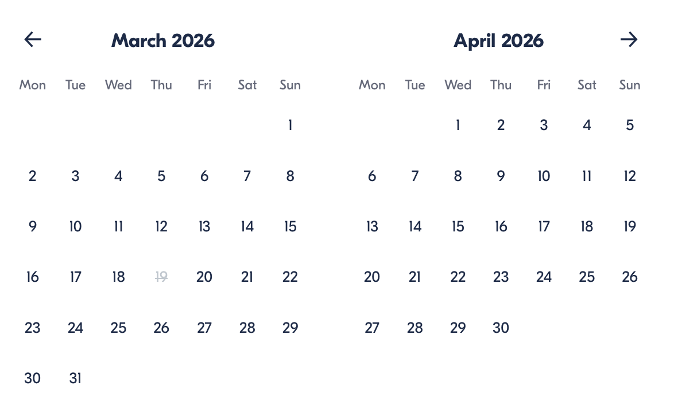

Check Availability

opens:

Participants: 1 March 16, 2026

DMZ Deep Dive: Private Peace Tour from Seoul with 3rd Tunnel, Dora Observatory & Suspension Bridge

- Duration: 6 days
- Offered in: English
- Starts at: 10:30 AM

Cancellation:

- More than 24 hours before start — Full refund
- 24 hours or less before start — No refund

Price breakdown: 1 Participant x €220

Total: €220

The total price includes all taxes and fees.

Add to cart Book now

__________________________________________________________
Tour Features
- Private DMZ Experience: No large groups—travel comfortably in your own vehicle.
- Imjingak Park Stops: See meaningful sites before the DMZ ID check area.
- 3rd Infiltration Tunnel: Visit the tunnel discovered in 1978, dug under the DMZ.
- Dora Observatory: Look toward North Korea on clear days.
- Nature Add-On: Choose Gamaksan Chulleong Bridge (Option 1) or Majang Lake (Option 2).
__________________________________________________________
Detailed Itinerary

Day 1 – Private DMZ Route + Nature Highlight
Hotel Pickup (Seoul area)
Start with convenient pickup and travel in a private, air-conditioned vehicle.
Imjingak Park (pre-DMZ stops + ID check prep)
Before entering the DMZ area for ID checks, you’ll visit key locations in Imjingak Park:
- Bridge of Freedom (approx. 15 min, free admission)
- Mangbaedan Altar
- War-damaged steam locomotive
The Third Tunnel (Monorail)
Explore the 3rd Infiltration Tunnel, discovered in 1978—a tunnel dug under the DMZ. (Approx. 40 min, free admission)
Dora Observatory
From the observatory on Mt. Dora, take in views toward the Gaeseong Industrial Complex, Mt. Songak, and other North Korean landmarks on clear days. (Approx. 20 min, free admission)
Imjingak Pyeonghoa-Nuri Park (pass by)
Drive past the peace-focused park area built to promote reunification and cultural events.
Choose one option to finish the day:
- Option 1: Gamaksan Chulleong Bridge — part of a short hike with scenic views from the mountain area (approx. 1 hour, free admission)
- Option 2: Majang Lake — a location connected to Korean War history, with flexible time on site (free admission)
Return & Drop-off (Seoul)
You’ll be dropped off at the exact location you request in the Seoul area.
Accommodation:
Not included (day tour)
__________________________________________________________
Included in Price
- Private tour (your group only)
- Professional driving tour guide
- Private transportation in an air-conditioned vehicle
__________________________________________________________
Not Included
- Lunch
- Travel insurance
- Gratuities
- Anything not listed in “Included”
__________________________________________________________
Who Should Avoid This Tour
- Wheelchair users (not suitable)
- Travelers with heart problems or serious medical conditions
- Travelers with back problems
- Guests unable to manage moderate physical activity (moderate fitness level required)
__________________________________________________________
Important Trip Info
- A current, valid passport is required on the day of travel, and passport details (name, number, expiry, country) are required at the time of booking.
- The itinerary may change due to unexpected circumstances, including military schedule changes, traffic, or weather.
- Infants must sit on laps.
- Adult pricing applies to all travelers except infants.
- Dress code: Smart casual
- A minimum of 2 people per booking is required.
- This is a private tour—only your group participates.
__________________________________________________________

Cancellation Policy
- More than 24 hours before start — Full refund
- 24 hours or less before start/no-show — No refund
__________________________________________________________
What Our Clients Are Saying

Overall rating  4.7/5  ★★★★★  Based on 20 reviews | Review summary  Guide 4.5/5  Transportation 4.6/5  Service 4.7/5  Organisation 4.5/5

Filter  - All traveller types  - Couples  - Group of friends  - Families  By star rating  - All star ratings  - 5 stars  - 4 stars  - 3 stars  - 2 stars  - 1 star | Search reviews (e.g., guide)  Sort by:  - Top picks  - Latest reviews  - Best ratings  - Lowest ratings
__________________________________________________________
★★★★★
Jennifer S. — United States
The guide explained the history clearly, and visiting the 3rd Tunnel was unforgettable. The suspension bridge was a standout moment.
★★★★★
Lee M.-h. — South Korea
Private format made everything smoother. The DMZ sites were meaningful, and the monorail/tunnel visit was very memorable.
★★★★★
Emily C. — Canada
Hotel pickup was easy, and the plan felt well-paced. The Dora Observatory and the tunnel visit were the highlights for me.
★★★★★
Hiroshi T. — Japan
Informative and well-organized. The DMZ sites were sobering, and the views from the bridge were impressive.
★★★★★
Sophie M. — France
A powerful day with a passionate guide. The tunnel visit and observatory views made a lasting impression.
See more reviews
__________________________________________________________

Meta tags

Page - DMZ Deep Dive: Private Peace Tour from Seoul with 3rd Tunnel, Dora Observatory & Suspension Bridge

Title: DMZ Deep Dive: Private Peace Tour from Seoul with 3rd Tunnel, Dora Observatory & Suspension Bridge | Travellio Global

Description: Explore Korea’s DMZ on a private day tour from Seoul with hotel pickup, an English-speaking guide, the 3rd Infiltration Tunnel (monorail), Dora Observatory views, and a scenic suspension bridge or lake option.

H1 - DMZ Deep Dive: Private Peace Tour from Seoul with 3rd Tunnel, Dora Observatory & Suspension Bridge
__________________________________________________________

